1. Click windows key on keyboard

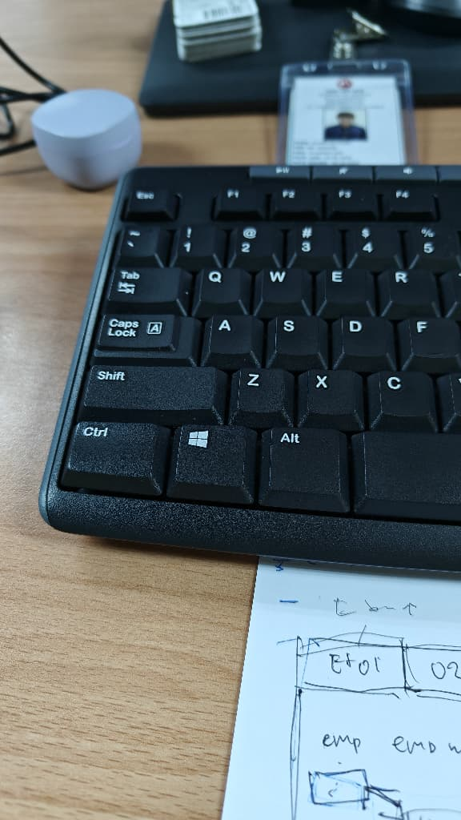

1. Type “Device Manager”

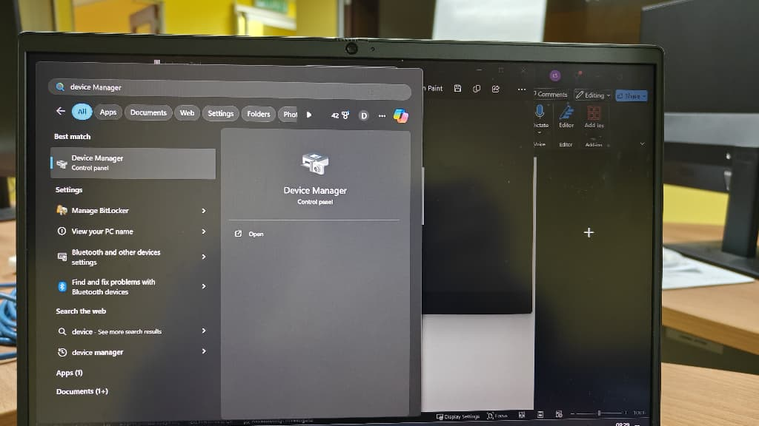

1. Find Ports (COM & LPT)

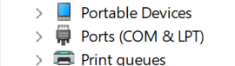

1. Remember which COM (e.g. COM20)

1. Open software DEMO.exe



1. Interface of the software

1. Focus here change

1. Select the COM that you get from Device Manager (eg.COM20)

1. Click Open

1. Focus here

1. Put your RFID tags on RFID Reader

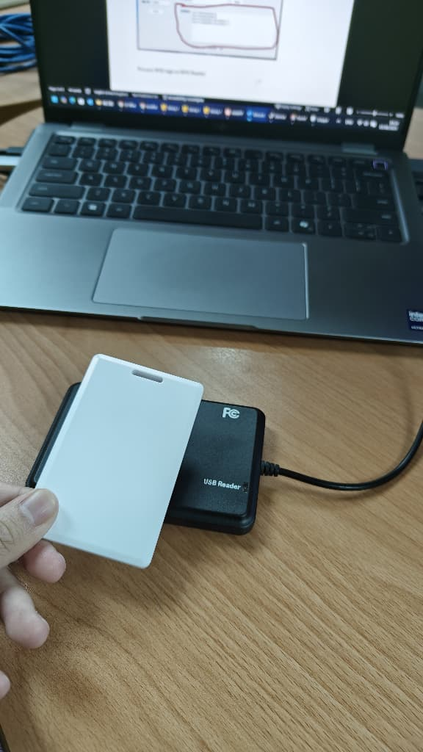

1. Wait new record coming, copy the text highlighted (**0007ADA9**).

**Same position**

**8 digit number**

**No spacing**

1. **Paste in the system**